**Shellbau installation instruction**

Shellbau panels are stored on pallets horizontally, protecting them from moisture and dust. The panels must be evenly supported over their entire surface. Before installation, Shellbau must be stored under the humidity conditions that will match their future usage conditions.

**Installation of foundation panels**

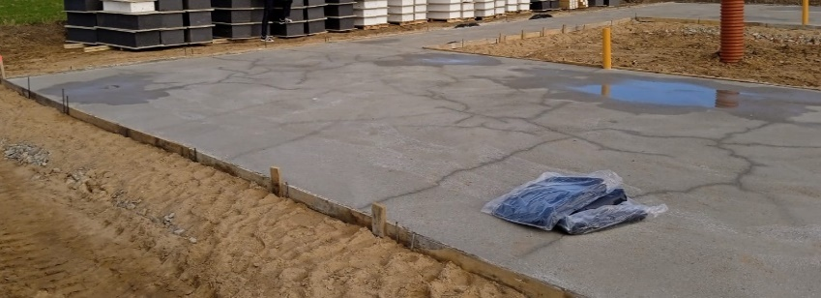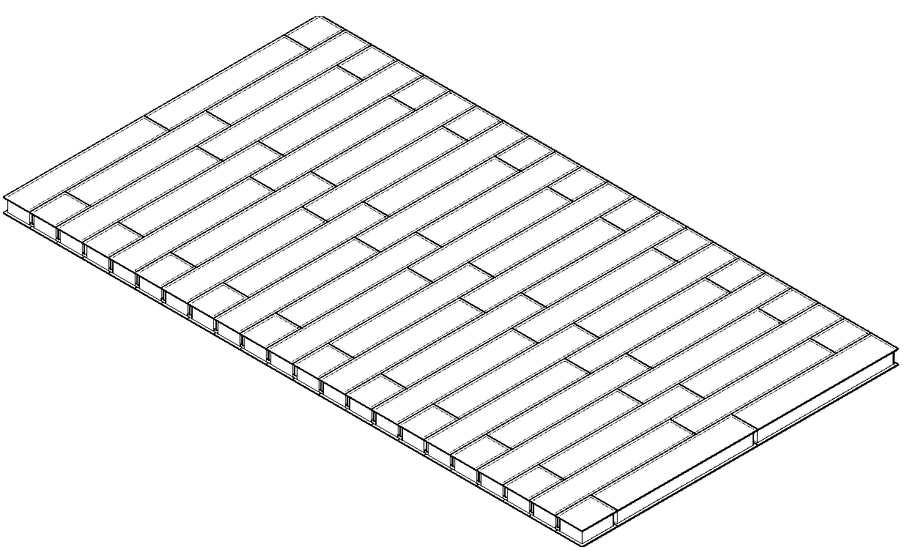In the first stage, the perimeter is marked using a string or a laser level, and the perpendicularity (90 degrees) of the edges is marked (see Fig. 1). Standard Shellbau panels are typically installed on flat (recommended) or strip foundations.

**Fig 1.** *Plane foundation*

When installing on strip foundations, additional wooden load-bearing beams are installed for the Shellbau panel installation. The distance between the beams should not exceed 1500 mm. The standard dimensions of Shellbau floor panels are 600x3000x(150-300) mm.

**Fig. 2.** *Foundation slab assembly diagram*

When installing Shellbau panels, the panels are joined with an insulated media beam. The joints between the panels and the connecting beam are sealed with polyurethane foam (see Fig. 3). To ensure maximum airtightness, the joint of floor panels is covered with silicone (see Fig. 4). The narrow part of the panels (600 mm) is connected to each other using an insulating polystyrene board and polyurethane foam.

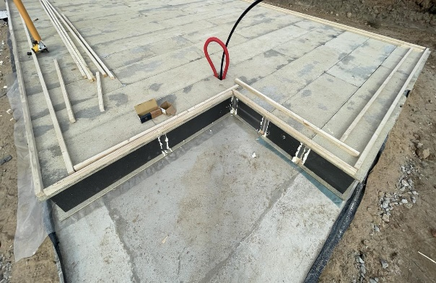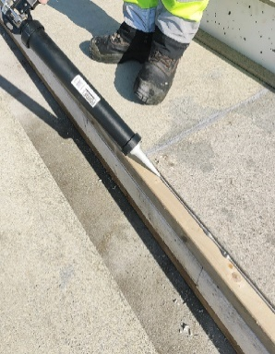 Cement slabs are installed on the vertical panel surfaces

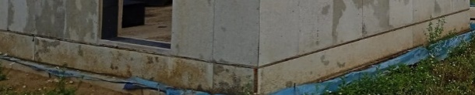to protect the insulation material from atmospheric effects (see Fig. 5). Shellbau floor panels are not the final floor covering. The panels need to be covered with waterproofing and the actual floor covering (tiles, PVC, wooden planks, etc.).

**Fig. 3.** *Joining of foundation slabs* **Fig.****4.** *Sealing of foundation slabs*

**Fig. 5.** *Covering of foundation slabs with cement panels*

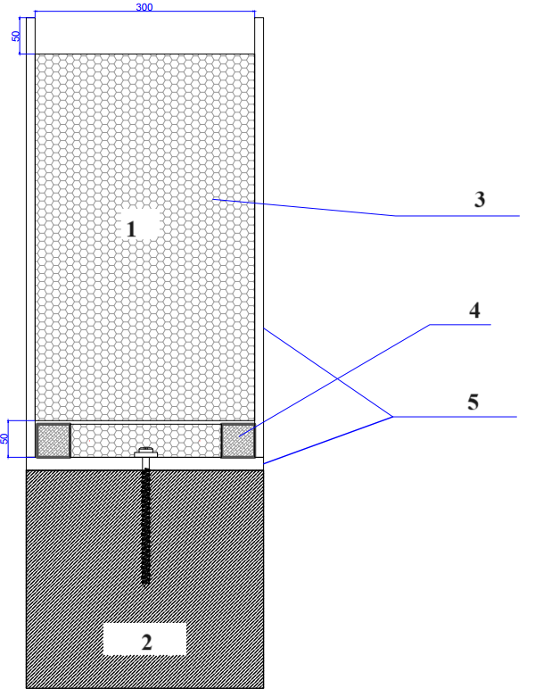

1. Shellbau wall panel

2. Foundation

3. Thermal insulation

4. Wooden blocks 45x45 mm

5. Cement slab 3000x600x12 mm

**Fig.6.** *Assembly of the foundation on strip foundations*

**Installation of wall panels**

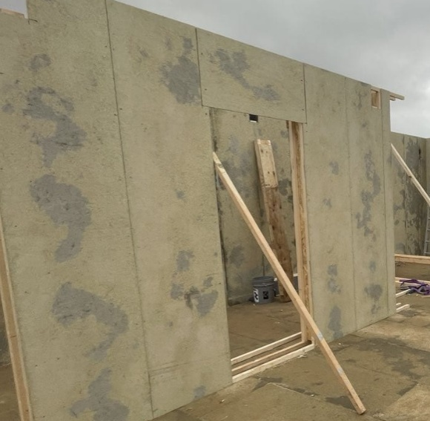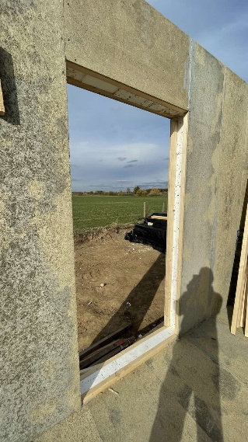Shellbau wall panels are mounted on the floor panels. Before installing the panels, wooden starting blocks (45x45 mm) are mounted first. The gap between the blocks is insulated with insulating material and sealed with polyurethane foam.

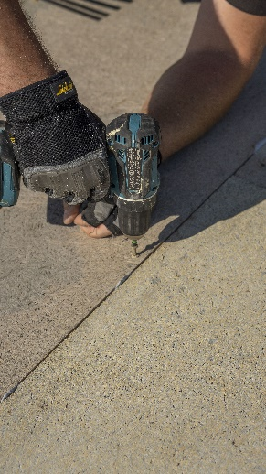The Shellbau wall panels measuring 600x3000x300 mm are mounted on the starting blocks. The panels are joined together with I-beams. The junctions between the connecting beams and the panels are sealed with polyurethane foam (see Fig. 7 and 9). Spaces between cement slabs are sealed with sealant. Additionally, Shellbau panels are mechanically fastened to the I-beam using self-tapping screws or anchors. During installation, the walls are secured diagonally to the floor panels to ensure perpendicularity (see Fig. 7). A spirit level or laser is used to determine the wall's straightness.

**Fig. 7.** *Installation of wall panels*

Installation of windows and doors

When preparing openings for windows and doors in the factory, the panels are pre-cut to the dimensions specified in the project. The panels are joined together with I-beams. The joints are sealed with polyurethane foam (see Fig. 10). Additionally, SIP panels are mechanically attached to the double beam using self-tapping screws or anchors.

**8 pav.** *Mechaninis*

*tvirtinimas*

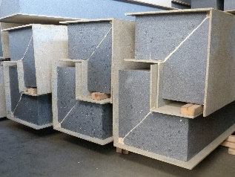Corner connection Corner connections are made using corner details or panels cut at a 45-degree angle and joined together (see Fig. 9 and 13). The connection area is sealed with polyurethane foam.

**Fig. 9 .** *Shell bau corner details*

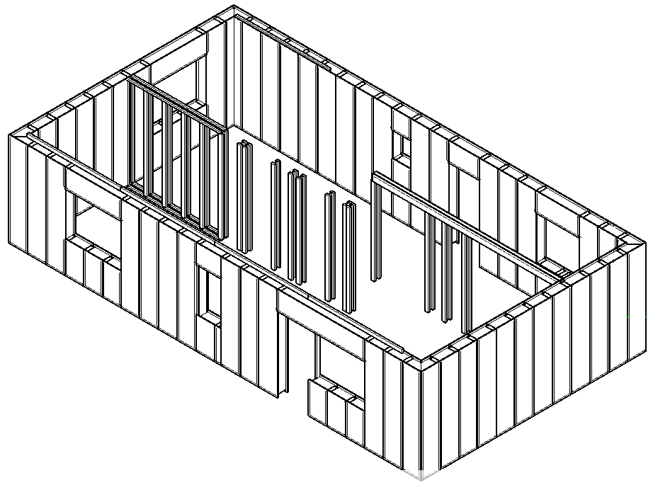

**Fig. 10.** *Assembly of Shellbau walls, windows, and partitions. General view.*

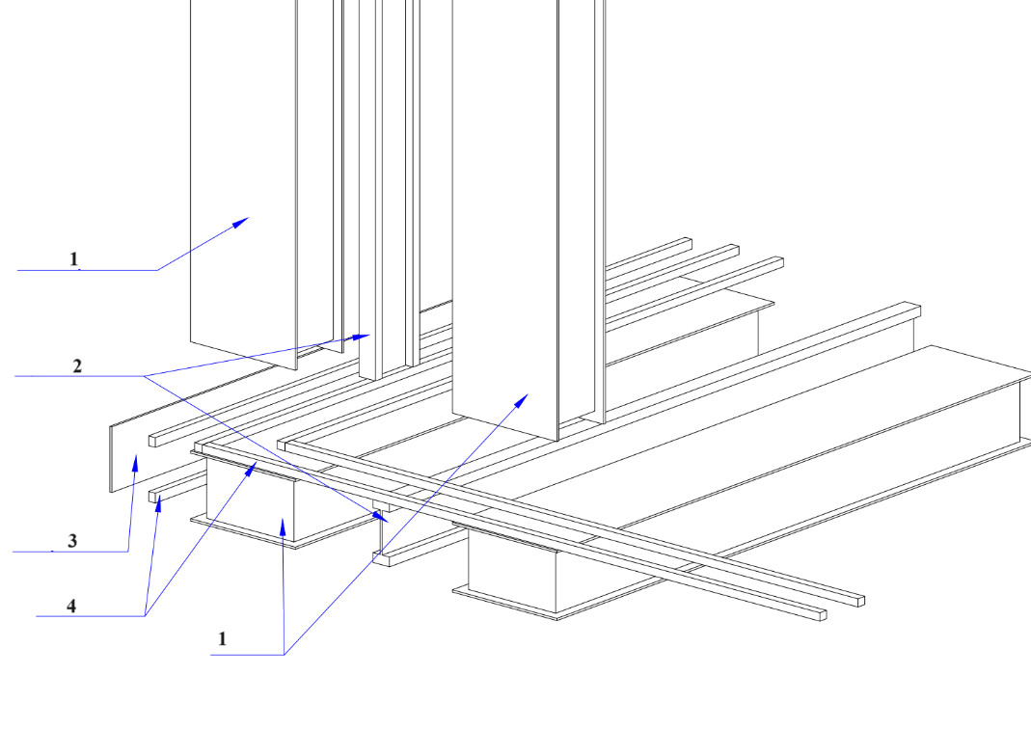

1. Shellbau foundation panel

2. Insulated beam

3. Cement slab

4. Wooden blocks 45x45 mm

**Figure 11.** *Diagram of Panel Assembly on the Foundation*

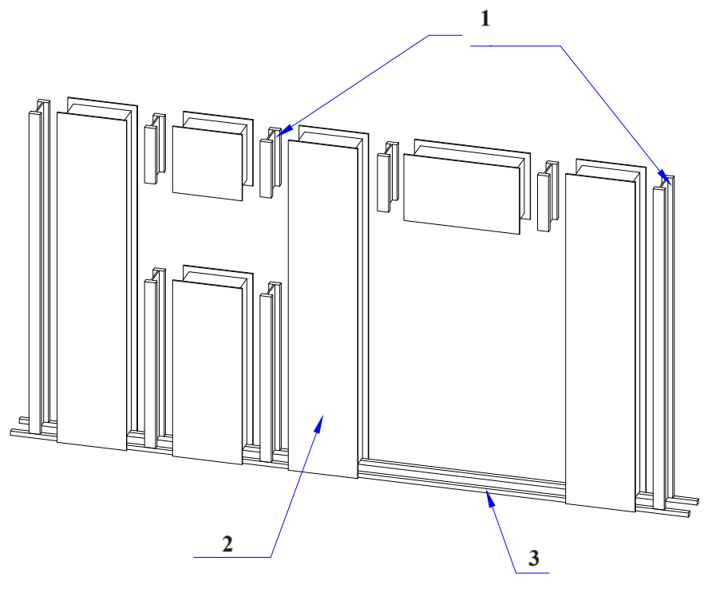

1. Insulated beam

2. Shellbau panel

3. Wooden block 45x45 mm

**Fig. 12.** *Assembly of Shellbau walls and windows*

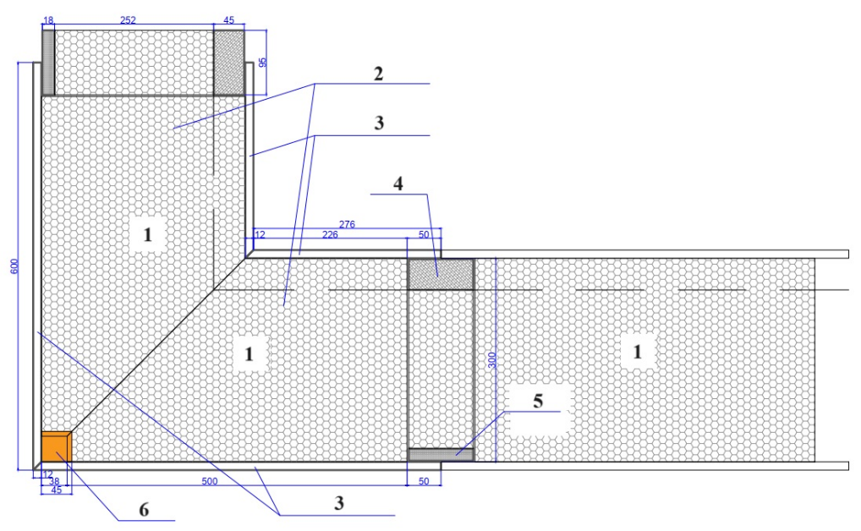

1. Shellbau wall panel

2. Insulation

3. Cement slab 3000x600x12 mm

4. Wooden block 95x45 mm

5. Veneer 95x18 mm

6. Wooden block 45x45 mm

**Fig. 13.** *Horizontal section view of a wall from above*

**Roof installation**

Roof installation. There are two types of roofs: pitched or flat.

* 1. 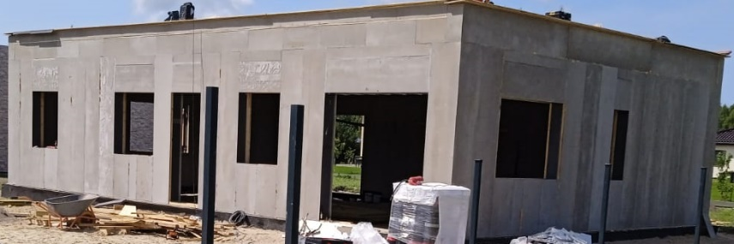Flat roof installation. Installation of a flat roof is similar to the assembly of the floors. A insulated beam is installed on top of Shellbau wall panels to level the base. Shellbau floor panels are mounted on the perimeter beams, which are joined with an insulated media beam. Joints are sealed with polyurethane foam and mechanically fastened with self-tapping screws or anchors. A cement slab is installed on the vertical panel surfaces to protect the insulation material from atmospheric effects. The roof structure must be additionally protected from atmospheric effects by installing an additional roofing membrane.

**Fig. 14.** *Installation of Shelbau flat roof*

* 1. 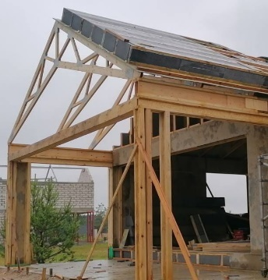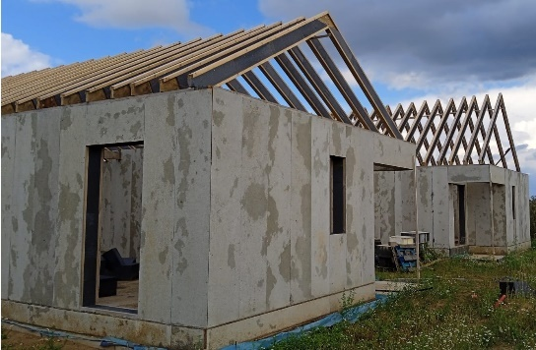Pitched roof installation When installing a pitched roof, a wooden framework is mounted on the SIP walls, to which SIP panels are attached. The design of the framework depends on the gap between supporting walls, the roof pitch, and the type of roofing material (see Fig. 7 and 9).

**Fig. 15.** *Installation of Shelbau pitched roof*

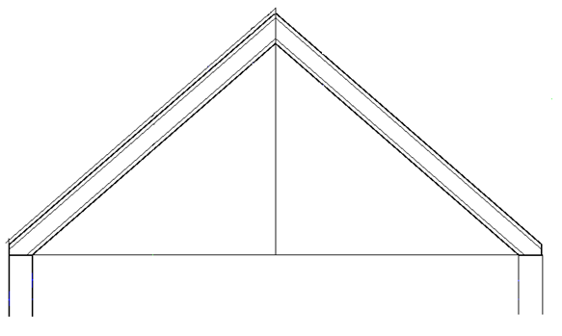

**Fig. 16.** *Assembly* *diagram of a pitched roof*

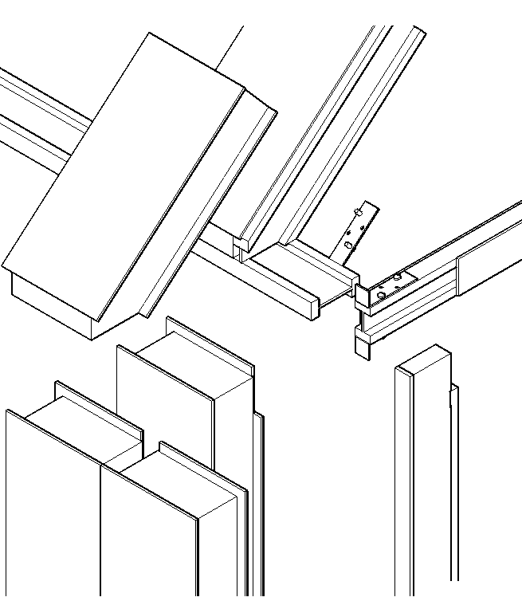 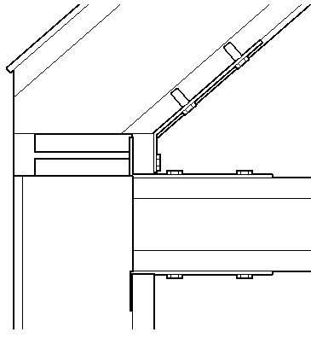

**Fig. 17.** *Scheme of pitched roof assembly*

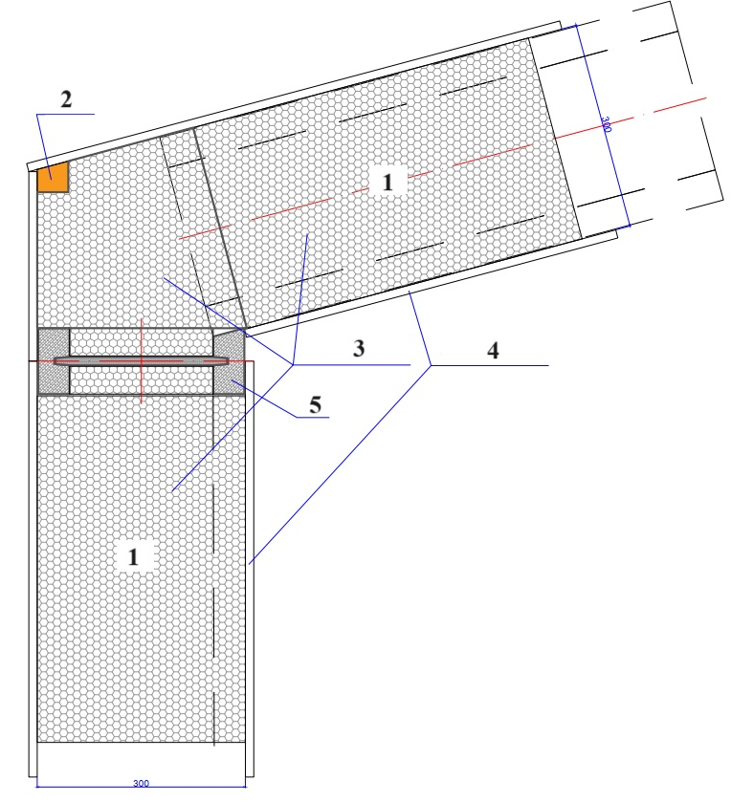

**Fig. 18.** *Connection of pitched roof walls with the roof, horizontal section of the wall*

1. Shellbau wall and roof panel

2. Wooden block 45x45 mm

3. Insulation

4. Cement slab 3000x600x12 mm

5. I-beam

**Floor installation**

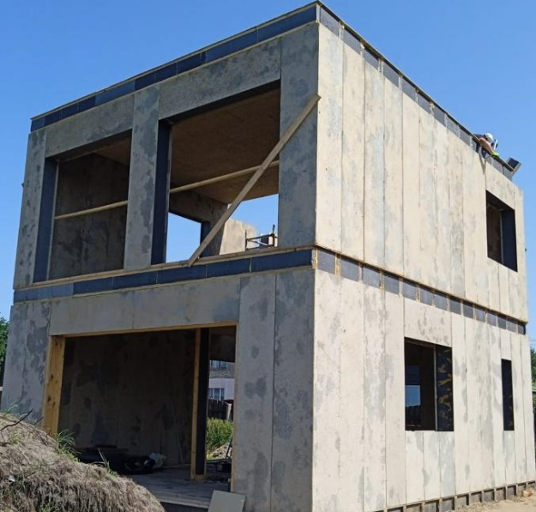Floor installation. An insulated beam is mounted on top of SIP wall panels to level the base. An I-beam is installed on top of SIP wall panels, and the spacing between the beams is calculated based on the expected loads on the second floor and the roof. SIP panels are installed on top of the floor beams, and they are joined with an insulated wooden beam. Joints are sealed with polyurethane foam and mechanically fastened with self-tapping screws or anchors.

**Fig 19.** *Installation of**Shellbau floor*

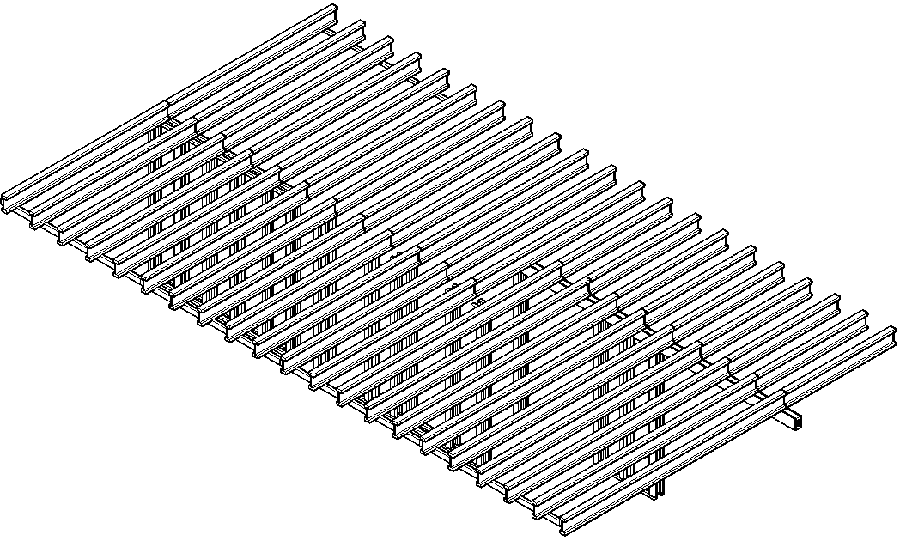

**Fig. 20.***Floor installation scheme.*

**Façade finish**

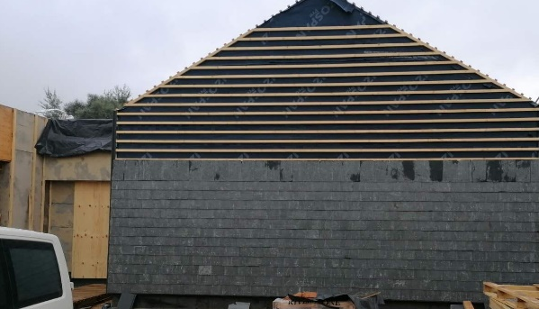The type of façade finishing is chosen based on aesthetic and functional properties. Two systems are used for Shellbau façade finishing: ventilated facade or structural plaster – tiles. There are no significant functional differences between the panels used in the ventilated façade and the plaster tiles. However, they may differ in terms of flammability and durability. It is critical to choose a reliable manufacturer because panels of the same type can have significant differences in characteristics depending on the manufacturer's technology, materials used, and compliance with technological processes. The manufacturer or their product distributor should provide certificates and panel test data, allowing to distinguish high-quality products. Resistance to atmospheric effects should be taken into account as it determines the rate of colour fading for panels and tiles. Separate evaluation criteria include UV resistance, the number of freeze-thaw cycles the panel can withstand, resistance to heat and cold, water absorption, resistance to pollutants and salts, expansion coefficient, resistance to impacts and scratches, and flammability class.

**Fig. 21.** *Facade finish with slate tiles*

**Fig. 22.** *Facade finish with tiles*

**SHELLBAU SYSTEM PARTS**

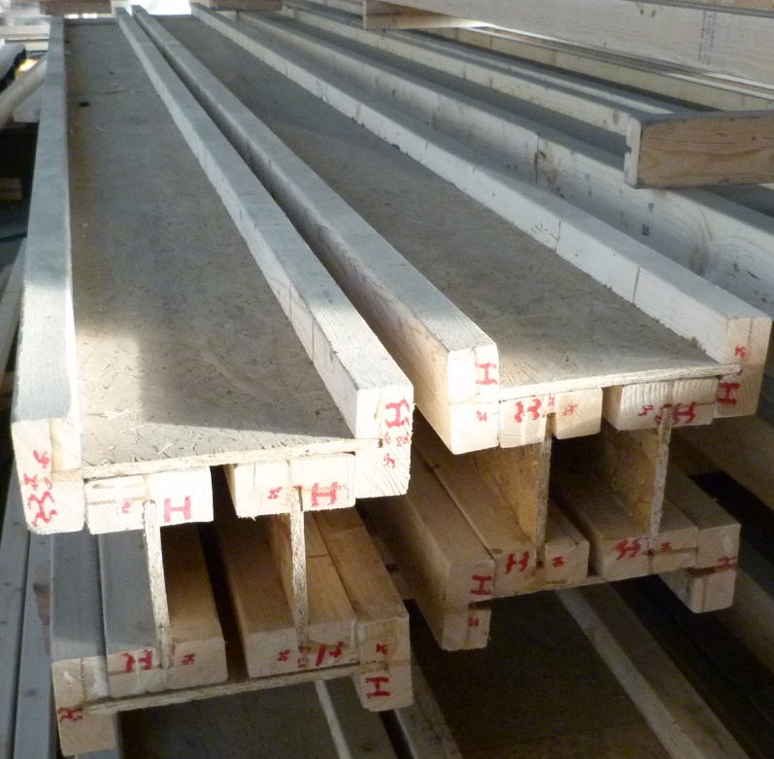 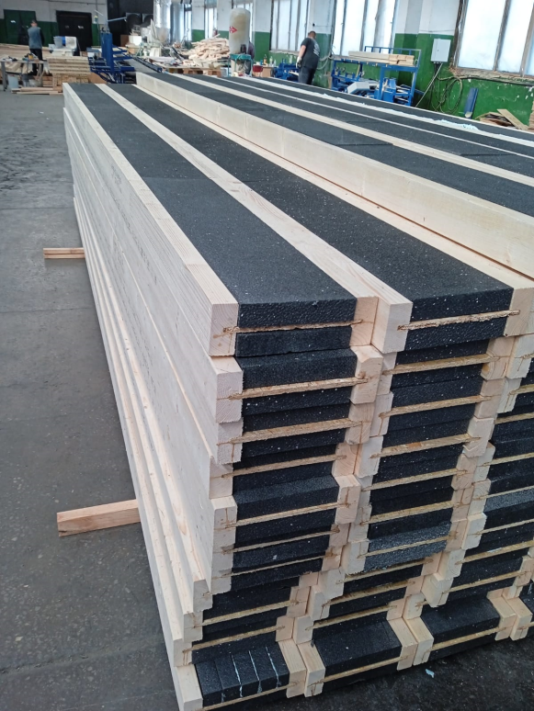

**Fig. 23.** *I-beams* **Fig. 24.** *Insulated I-beams*

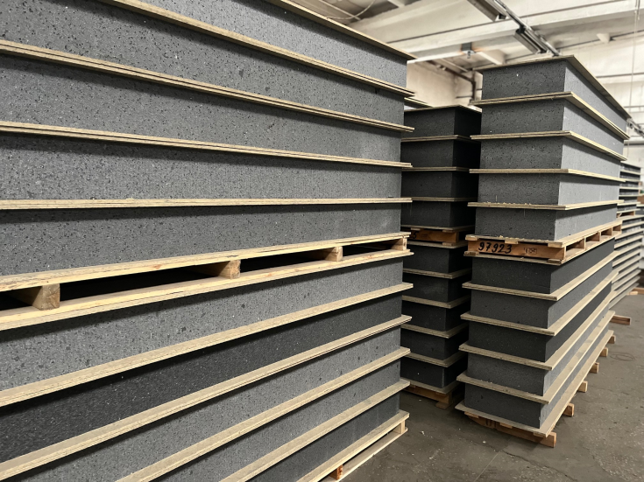 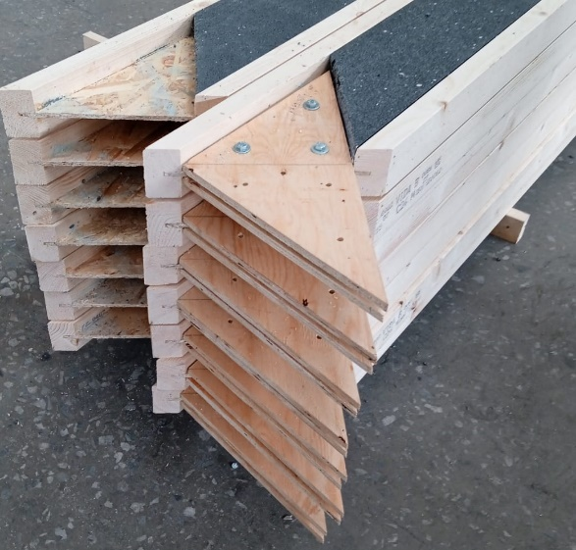

**Fig. 25.** *Shellbau panels* **Fig. 26 .** *Roof structures*

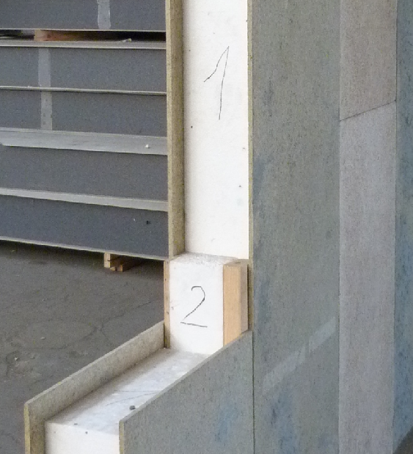

**Fig. 27.** *Panel connection assembly*